Parking Management System
Objective:-The objective is to create a project which will help the users in entry and exit parking slots . Automate the manual process of parking management. Maintain a record of vehicles parked entry/exit time, slot number using Tkinter.
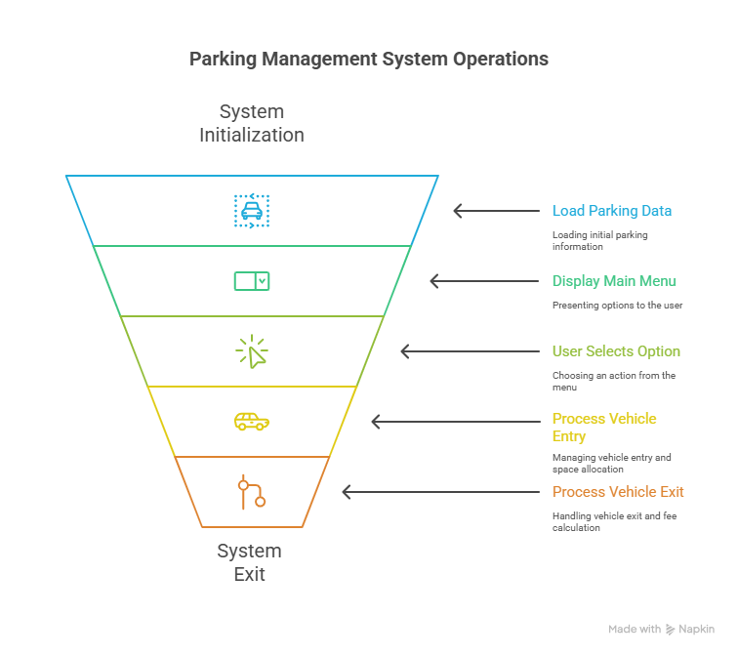
Menu Design:-
Step 1: Main Window
- The application opens with the main window titled “Parking Management System”.
- The main window serves as the central hub for all features, accessible through a menu bar at the top.

Step 2: Menu Bar
- A menu bar is provided at the top of the window.
- It contains five main menus: File, Vehicle, Slots, Reports, and Help.

Step 3: File Menu
- Exit: Closes the application safely.

Step 4: Vehicle Menu
This menu manages vehicle-related activities:
- Vehicle Entry
  - Opens a form to enter new vehicle details (number, owner, type).
  - Allocates a parking slot.
  - Stores entry time in the database.
- Vehicle Exit
  - Opens a form to record vehicle exit.
  - Calculates parking fee based on entry and exit time.Updates database and releases the slot.
- Search Vehicle
  - Allows the user to search for a specific vehicle by its number.
  - Displays details such as owner name, slot number, and entry/exit time.
Step 5: Slots Menu
This menu handles slot management:
- Available Slots
  - Displays the number and list of free slots.
- Occupied Slots
  - Displays the number and list of currently used slots along with assigned vehicle numbers.

Step 6: Reports Menu
For generating reports on parking usage:
- Daily Report
  - Summarizes vehicles parked during the day.
  - Displays revenue collected for that day.
- Monthly Report
  - Provides a monthly summary of vehicle entries, exits, and total revenue.
Step 7: Help Menu
- About
  - Displays project details, developer information, and usage instructions.

Tables for Data Storage:-
1. vehicles
Column Name | Data Type | Description
vehicle_id | INT (PK, Auto Increment) | Unique ID for each vehicle
vehicle_no | VARCHAR(20) | Vehicle registration number
vehicle_type | ENUM('2W','4W','Truck','Disabled') | Type of vehicle
user_id | INT (FK) | Owner/user of the vehicle
user_id | INT (PK, Auto Increment) | Unique ID for each user
mobile_no | VARCHAR(15) | User’s mobile number
parking_sticker | VARCHAR(20) | Parking sticker/ID (if issued)
pno | VARCHAR(20) | Parking pass number
vehicle_id | INT (FK) | Vehicle linked to the user

3. parking_slots
Defines available parking spaces and their status.
Column Name | Data Type | Description
slot_id | INT (PK) | Unique slot number
slot_type | ENUM('2W','4W','Truck','Disabled') | Type of slot
status | ENUM('Free','Occupied') | Slot availability
vehicle_id | INT (FK, Nullable) | Vehicle currently parked

4. parking_records
Keeps entry and exit details for each parked vehicle.
Column Name | Data Type | Description
record_id | INT (PK) | Unique record ID
vehicle_id | INT (FK) | Vehicle parked
slot_id | INT (FK) | Slot allocated
entry_time | DATETIME | Time of entry
exit_time | DATETIME | Time of exit
duration | INT | Total parking duration (in minutes/hours)

5. charges
Defines parking charges for different vehicle types and durations.
Column Name | Data Type | Description
charge_id | INT (PK) | Unique ID for charges
vehicle_type | ENUM('2W','4W','Truck','Disabled') | Vehicle category
rate_type | ENUM('Hourly','Daily','Monthly') | Charging model
amount | DECIMAL(10,2) | Rate amount

6. payments
Stores payment details for completed transactions.
Column Name | Data Type | Description
payment_id | INT (PK) | Unique payment record
record_id | INT (FK) | Linked to parking record
vehicle_id | INT (FK) | Vehicle making the payment
amount_paid | DECIMAL(10,2) | Total amount charged
payment_mode | ENUM('Cash','Card','Wallet','UPI') | Mode of payment
receipt_no | VARCHAR(30) | Unique receipt number

Table summary:-

- vehicles – Stores vehicle details.
- users – Stores user/customer details.
- parking_slots – Defines space and slot availability.
- parking_records – Tracks entry/exit of each vehicle.
- charges – Defines hourly/daily/monthly charges.
- payments – Handles payment and receipts.
- reports – Generated dynamically from other tables.
Classes And Methods:-
DatabaseManager
Handles all communication with MySQL. Provides methods to connect, execute queries, and fetch results.
Methods:
- connect() → Creates a database connection.
- execute_query(query, params) → Executes INSERT/UPDATE/DELETE queries.
- fetch_one(query, params) → Returns one record.
- fetch_all(query, params) → Returns multiple records.

ParkingSystem
Contains the business logic of the application. Uses DatabaseManager internally.
Methods:
- park_vehicle(vehicle_no, owner, slot) → Parks a vehicle if slot is available.
- exit_vehicle(vehicle_no) → Updates exit time, calculates fee, and sets status as Exited.
- search_vehicle(vehicle_no) → Returns details of a vehicle from DB.
- check_availability(total_slots=10) → Returns available slot numbers.

ParkingApp
Tkinter GUI layer that interacts with the user. It sends user input to ParkingSystem methods.
Methods:
- setup_ui() → Creates all labels, entry fields, and buttons.
- run() → Starts Tkinter main loop.
- Event-handlers like on_park_click(), on_exit_click(), etc. call respective ParkingSystem methods.

Software Requirements:
- Python 3.x(IDLE/Vscode)
- Tkinter (built-in Python library for GUI)
- MySQL / MySQL Workbench
- mysql-connector-python (for database connectivity)

